Human Papillomavirus Vaccine

Communication Action Plan

July 2018 - June 2019

**By**

**Patience Panganai**

**National HPV Vaccine Consultant**

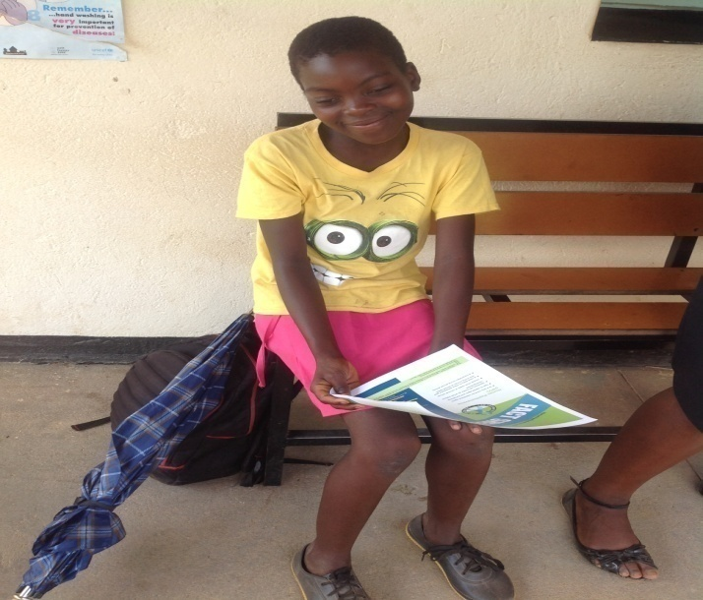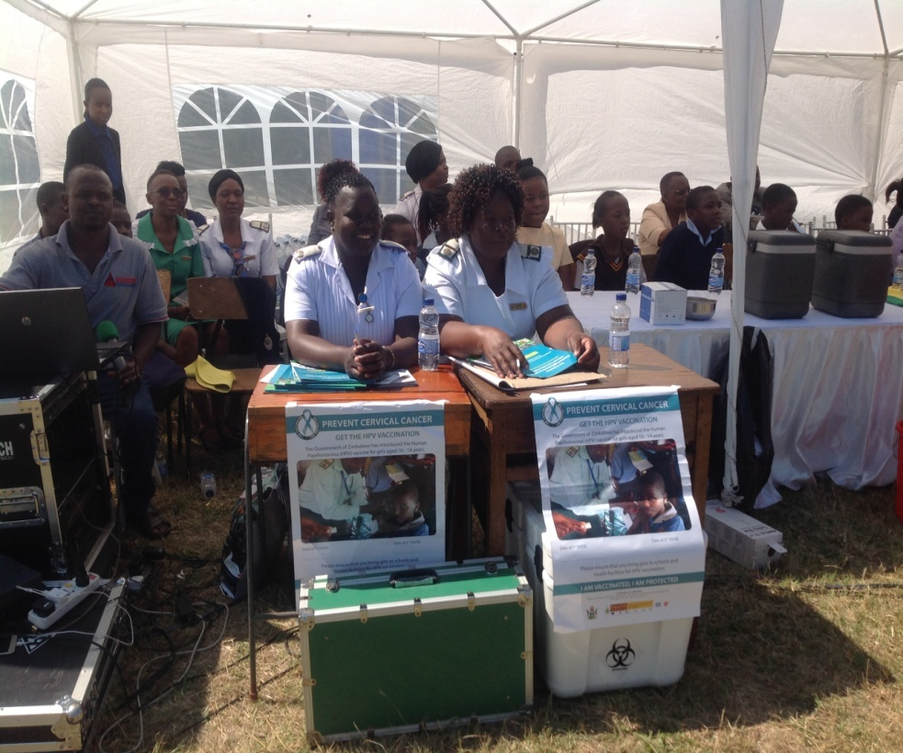

Bridging the communications gap between HPV1 and HPV2

Table of Contents

Introduction 3

Communication Objective 4

Human Papillomavirus Vaccine 2ndDose Roll Out & 1st Dose 2nd Cohort Communication Plan 5

Annex 1 17

Communication Plan HPV1 dose roll out 17

# 

# Introduction

For any vaccination programme, careful planning at the outset can ensure that the target population is reached and coverage is high. Managers who are beginning HPV vaccination programmes can make use of routine EPI planning processes found in their country immunization program materials, with the addition of school-specific plans if schools will be used as vaccination sites.

Zimbabwe rolled out the Human Papillomavirus (HPV) vaccine in May 2018 targeting an estimated 883 534[1] girls aged 10 – 14 both in and out of school. A total of 751 367 girls were reached by the vaccine recording a national coverage rate of 85%. The set coverage for HPV vaccination by Gavi, the vaccine alliance is 80%.

During the roll out of the first dose of the HPV vaccine Manicaland Province reached 95% of the target girls followed by Mashonaland West with a coverage rate of 92%. Mashonaland Central and Chitungwiza City both reached 86% of the target group, with Midlands at 83% followed close by Matebeleland South at 82%. In the campaign, Bulawayo and Harare City managed to protect 80% of the girls from cervical cancer through HPV vaccination. Mashonaland East reached 79% of the girls and Matebeleland North covered 68% of the girls failing to reach the Gavi, the vaccine alliance agreed coverage of 80%. Evidence shows that high HPV vaccine coverage reduces the economic and human costs of cervical cancer in the long term

To get full protection one has to get two doses of the vaccine. There is a gap of between 6 – 15 months apart *(12 months in Zimbabwe)* before the second dose is administered. This environment presents communicators with challenges of keeping the message on HPV vaccine alive for demand creation; and maintaining coverage from the first dose.

This plan seeks to:

1. bridge the communication gap between the two doses. It seeks to intensify the communications so that the provinces that did not perform well meet the targets and that the second cohort surpasses the target. There is need to come up with strategies and intensify the communications so that the provinces and communities that did not meet the 80% target surpass it in the coming year; and those that surpassed the target also increase the coverage rate to over 90%.
2. Create awareness for first dose HPV vaccination for grade 5 or 10 year old girls in May 2019.

The plan also builds on the communication plan implemented during the roll out of the first dose (*See Annex 1*). The communication plan also tries to complement the national HPV Communications Strategy.

The communication activities will be implemented at all levels, i.e national, provincial, district, health facility, community and in schools using multi C4D strategies for effective communication. The primary audience are caregivers and girls aged 10 – 14 years; and the secondary audience includes policy/decision-makers, service providers, community leaders, headmasters, teachers, organisations, youth groups and the media amongst others.

# Communication Objective

* To provide multi – C4D strategies that will effectively communicate on the HPV vaccine (and bridge the gap between the HPV vaccine first dose and second dose) to reach 90% of caregivers and girls aged between 10 – 14 years by May 2019.

# Human Papillomavirus Vaccine 2ndDose Roll Out & 1st Dose 2nd Cohort Communication Plan

|  |  |  |  |  |  |  |  |  |  |  |
| --- | --- | --- | --- | --- | --- | --- | --- | --- | --- | --- |
| **Communication Objective 1.1 To contribute towards adoption of improved caregivers and 10 year old girl’s (in and out of school) practices towards HPV vaccine immunisation by May, 2019**  **Communication Outcome1.1Caregivers and 10 year old girl’s (in and out of school) adopt improved HPV vaccine immunisations practices** | | | | | | | | | | |
| **Specific communication objective:** Caregivers and 10- 14 year old girl’s (in and out of school)have increased knowledge on the benefits of HPV vaccine vaccination | | | | | | | | | | |
| **Communication Activity** | | **Target Audience** | **Output** | | | **Resources** | | **Responsible person** | **Time Frame** | |
| Interpersonal communication (health education at health facilities, community visits by VHWs) | | Caregivers  10 – 14 year old girls  Community groups | Number of households/families reached | | | IEC materials | | Health Care Workers  VHWs | On- going | |
| Media campaigns (newspaper articles, radio programmes, TV programmes, social media- Whatsapp, U-report, Facebook, Twitter, SMS, MoHCC website) | | Communities | Number of girls aged 10 – 14 reached  Number of caregivers reached | | | Human | | MoHCC DEDC/ HP/PR/ RHU/NCDs | Monthly | |
| Interpersonal communication training | | VHWs, HCWs and SHMs | Number of VHWs, SHMs and HCWs trained in IPC  Number of trainings conducted | | | Training Manual  IEC materials (job aids, IEC materials)  Financial resources | | MoHCC HP/ DEDC/EPI/Nursing Services/ Community Nursing | Bi-annually | |
|  | |  |  | | |  | |  |  | |
| School health programmes | | Caregivers  SDC Reps  Teachers  Pupils  MoPSE | Number of schools reached  Number of caregivers and SDC members reached | | | Fuel  IEC materials | | MoHCC HP/EPI/ Community Nursing/ MoPSE | Quarterly | |
| Advocacy at policy level and community leaders (parliamentarians, chiefs, village heads, religious | | parliamentarians, chiefs, village heads, religious leaders | Number of community leaders reached | | | Financial resources – fuel, refreshment | | MoHCC HP/DEDC/EPI/Community Nursing/ Local Gvt/ | Annual | |
| **Specific communication Objective:** Caregivers and 10 – 14 year old girl’s (in and out of school)have increased knowledge on the benefits of HPV vaccine vaccination | | | | | | | | | | |
| Interpersonal communication (health education at health facilities, community visits by VHWs) | | Caregivers  10 – 14 year old girls | Number of households/families reached | | | IEC materials | | Health Care Workers  VHWs | On- going | |
| Media campaigns (newspaper articles, radio programmes, TV programmes, social media- Whatsapp, U-report, Facebook, Twitter, SMS, MoHCC website) | | Communities | Number of girls aged 10 – 14 reached  Number of caregivers reached | | | Human | | MoHCC DEDC/ HP/PR/ RHU/NCDs | Monthly | |
| Interpersonal communication training for VHWs, HCWs and SHMs | | VHWs, HCWs and SHMs | Number of VHWs, SHMs and HCWs trained in IPC  Number of trainings conducted | | | Training Manual  IEC materials (job aids, IEC materials)  Financial resources | | MoHCC HP/ DEDC/EPI/Nursing Services/ Community Nursing | Bi-annually | |
| School health programmes | | Caregivers  SDC Reps  Teachers  Pupils  MoPSE | Number of schools reached  Number of caregivers and SDC members reached | | | Fuel  IEC materials | | MoHCC HP/EPI/ Community Nursing/ MoPSE | Quarterly | |
| Advocacy at policy level and community leaders | | parliamentarians, chiefs, village heads, religious leaders | Number of community leaders reached | | | Financial resources – fuel, refreshment | | MoHCC HP/DEDC/EPI/Community Nursing/ Local Gvt/ | Annual | |
| **Specific communication objective:** Caregivers perceive the HPV Vaccine as safe and effective in preventing cervical cancer | | | | | | | | | | |
| Interpersonal communication (health education at health facilities, community visits by VHWs) | | Caregivers  10 – 14 year old girls  Community groups | Number of households/families reached | | | IEC materials | | Health Care Workers  VHWs | On- going | |
| Media campaigns (newspaper articles, radio programmes, TV programmes, social media- Whatsapp, U-report, Facebook, Twitter, SMS, MoHCC website | | Communities | Number of girls aged 10 – 14 reached  Number of caregivers reached | | | Human | | MoHCC DEDC/ HP/PR/ RHU/NCDs | Monthly | |
| Interpersonal communication training | | VHWs, HCWs and SHMs | Number of VHWs, SHMs and HCWs trained in IPC  Number of trainings conducted | | | Training Manual  IEC materials (job aids, IEC materials)  Financial resources | | MoHCC HP/ DEDC/EPI/Nursing Services/ Community Nursing/MoPSE | Bi-annually | |
| Advocacy at policy level and community leaders | | parliamentarians, chiefs, village heads, religious leaders | Number of community leaders reached | | | Financial resources – fuel, refreshment | | MoHCC HP/DEDC/EPI/Community Nursing/ Local Gvt/ | Annual | |
| **Specific communication objective:** Increasing knowledge on cervical cancer and adolescent, sexual and reproductive health among 10 – 14 year old girls (in and out of school). | | | | | | | | | | |
| Interpersonal communication (health education at health facilities, community visits by VHWs) | | Caregivers  10 – 14 year old girls  Community groups | Number of households/families reached | | | IEC materials | | Health Care Workers  VHWs | On- going | |
| Media campaigns (newspaper articles, radio programmes, TV programmes, social media- Whatsapp, U-report, Facebook, Twitter, SMS, MoHCC website) | | Communities | Number of girls aged 10 – 14 reached  Number of caregivers reached | | | Human | | MoHCC DEDC/ HP/PR/ RHU/NCDs | Monthly | |
| Interpersonal communication training | | VHWs, HCWs and SHMs | Number of VHWs, SHMs and HCWs trained in IPC  Number of trainings conducted | | | Training Manual  IEC materials (job aids, IEC materials)  Financial resources | | MoHCC HP/ DEDC/EPI/Nursing Services/ Community Nursing/MoPSE | Bi-annually | |
| School health programmes | | Caregivers  SDC Reps  Teachers  Pupils  MoPSE | Number of schools reached  Number of caregivers and SDC members reached | | | Fuel  IEC materials | | MoHCC HP/EPI/ Community Nursing/ MoPSE | Quarterly | |
| Advocacy at policy level and community leaders | | parliamentarians, chiefs, village heads, religious leaders | Number of community leaders reached | | | Financial resources – fuel, refreshment | | MoHCC HP/DEDC/EPI/Community Nursing/ Local Gvt/ | Annual | |
| **Specific communication objective:** Advocacy to promote improved caregivers and 10 – 14 year old girl’s (in and out of school) practices towards HPV vaccine immunisation | | | | | | | | | | |
| Advocacy dialogues with policy/decision-makers | | parliamentarians, chiefs, village heads, religious leaders | Number of policy/ decision makers reached | | | Financial resources | | Financial resources | Bi- annually | |
| Interpersonal communication (health education at health facilities, community visits by VHWs) | | Caregivers  10-14 year old girls  Community groups | Number of households/families reached | | | IEC materials | | Health Care Workers  VHWs | On- going | |
| Media campaigns (newspaper articles, radio programmes, TV programmes, social media- Whatsapp, U-report, Facebook, Twitter, SMS, MoHCC website) | | Communities | Number of girls aged 10 – 14 reached  Number of caregivers reached | | | Human | | MoHCC DEDC/ HP/PR/ RHU/NCDs | Monthly | |
| Interpersonal communication training | | VHWs, HCWs and SHMs | Number of VHWs, SHMs and HCWs trained in IPC  Number of trainings conducted | | | Training Manual  IEC materials (job aids, IEC materials)  Financial resources | | MoHCC HP/ DEDC/EPI/Nursing Services/ Community Nursing/MoPSE | Bi-annually | |
| School health programmes | | Caregivers  SDC Reps  Teachers  Pupils  MoPSE | Number of schools reached  Number of caregivers and SDC members reached | | | Fuel  IEC materials | | MoHCC HP/EPI/ Community Nursing/ MoPSE | Quarterly | |
| **Communication Objective 2.1 To contribute towards demand creation for HPV vaccine vaccinations for all eligible girls by May 2019**  **Communication Outcome 2.1 All eligible girls getting their dose of HPV Vaccine for prevention from cervical cancer** | | | | | | | | | | |
| **Specific communication objective:** To create awareness of the HPV vaccine through C4D activities | | | | | | | | | | |
| **Communication Activity** | **Target Audience** | | | **Output** | **Resources** | | **Responsible person** | | | **Time Frame** |
| Launch the cervical cancer awareness month/week | Different stakeholders/partners | | | Number of village leaders, legislators, community members and advocacy persons reached | Venue  Refreshments  IEC materials  Allowances | | MoHCC HP/NCDs/DEDC/CAZ | | | January 2019 |
| Commemoration of International HPV awareness day | Different stakeholders/partners | | | Number of village leaders, legislators, community members and advocacy persons reached | Venue  Refreshments  IEC materials  Allowances | | MoHCC HP/EPI/DEDC/  EPI partners | | | March 2019 |
| Training on IPC | VHWs, SHMs, HCWs | | | Number of VHWs, SHMs and HCWs trained in IPC | Training manuals  Venue  Refreshments  Stationery  Fuel  Allowances | | MoHCC HP/EPI/DEDC/EPI partners/MoPSE | | | September 2018  March 2019 |
| School meetings and or school health programmes | Caregivers  SDC Reps  Teachers  Pupils  MoPSE | | | Number of schools reached  Number of caregivers and SDC members reached | Financial – Refreshments  Fuel | | MoHCC HP/MoPSE | | | April 2019 |
| Distribution plan and distribution of IEC Materials | Mass audience/Communities | | | Number of IEC materials distributed disaggregated by type (Fliers, Brochures, Pamphlets, Posters etc) | Financial  Fuel | | MoHCC HP | | | Feb/March 2019 |
| PSAs on radio/television in different languages | Mass audience/Communities | | | Number of PSAs aired on radio disaggregated into different languages | Financial | | MoHCC HP | | | March/April/May/June 2019 |
| Community activities by VHWs ( home visits to identify OOS girls, community meetings and mobilisation for HPV vaccineetc) | Communities | | | Number of households visited  Number of community meetings held  Number of people reached | Financial  Fuel | | VHWs/Community Nurse/MoHCC HP | | | On- going |
| Branding on HPV Vaccine using logo, signature emails with logo, branded stationery( books, rulers, pens) | Mass audience/ Communities | | | Number of personnel with signature email with HPV logo  Number of books, rulers and pens with HPV logo distributed | Financial | | MoHCC HP/PR/DEDC/EPI | | | January 2019 |
| Media campaign activities/community radio drama | Mass audience/community | | | Number of people reached by radio drama | Financial | | MoHCC HP/PR/DEDC/EPI/Radio drama script writing and production company | | | October 2018 – March 2019 Production  April 2019 – May 2019 Airing of Radio drama |
| Advocacy and community dialogues with special populations | Special populations including religious objectors, the urban elites, private schools reps, Rotary Club etc | | | Number of the special populations reached | Financial - ,Fuel and refreshments, DSAs | | MoHCC HP/DEDC | | | September 2018  March 2019 |
| **Communication Objective 3.1 To promote uptake of 2nd dose of HPV Vaccine in communities by May 2019**  **Communication Outcome 3.1 Adoption of behaviours that contribute towards prevention of cervical cancer** | | | | | | | | | | |
| **Specific communication objective:** To promote the benefits of HPV vaccination and contribute towards prevention of cervical cancer | | | | | | | | | | |
| **Communication Activity** | **Target Audience** | | | **Output** | **Resources** | | **Responsible person** | | | **Time Frame** |
| HPV Vaccine TWG meetings | MoHCC EPI Unit  EPI Partners | | | Number HPV Vaccine TWG meetings conducted | Venue | | MoHCC HP/DEDC/EPI | | | Monthly |
| Sensitisation meetings for leaders | community leaders –political, church and traditional leaders | | | Number of leaders reached | Allowances,  Refreshments, bus fare, fuel, Stationery | | MoHCC HP/EPI | | | Bi- annually |
| Community sensitisation meetings | Community groups | | | Number of community members reached | Allowances, refreshments | | MoHCC HP | | | On- going |
| Commemorate cancer related days/months | Communities | | | Number of people reached  Number of commemorations done | Refreshments  Fuel  IEC materials | | MoHCC HP/DEDC/DCN/PR | | | On- going |
| Updating, revising, printing and distributing IEC materials on HPV vaccine | Communities | | | Numbers of materials produced and distributed by type | Allowances  Production costs | | MoHCC HP | | | October 2018 to March 2019 |
| Press conference on the HPV vaccine roll out | Communities | | | Number of media houses present at the press conference | Refreshments  Venue | | MoHCC HP/PR/DEDC | | | May 2019 |
| Post HPV vaccine campaign 30 days vaccination messages | Communities | | | Number of people reached with the message via U report/SMS bulk messages | Messages | | MoHCC HP/DEDC/UNICEF | | | May – June 2019 |
| **Communication Objective 4.1To promote HPV vaccine programming in other health programmes *(EPI/RH/NCDs/ ASRH/HIV AIDS)***  **Communication Outcome 4.1 Mainstreaming of HPV vaccine in different health programmes** | | | | | | | | | | |
| **Specific communication objective: To promote the inclusion of HPV key messages in other health programmes** | | | | | | | | | | |
| **Communication Activity** | **Target Audience** | | | **Output** | **Resources** | | **Responsible person** | | | **Time Frame** |
| Conduct stakeholder HPV vaccine meetings | Stakeholders | | | Number of stakeholders reached | Venue  Stationery  Refreshments | | MoHCC HP/DEDC/EPI | | | Bi- annually |
| Sensitise other health programmes/ stakeholders on HPV communication strategy and plan | Stakeholders  MoHCC Health Programmes  MoHCC EPI partners  TWGs | | | Number of representatives from other health programmes and stakeholders reached | Stationery  Venue  Refreshments | | MoHCC HP/DEDC/DDCN/RHU/NCDs/ASRH/ | | | Annual |
| Training of VHWs, HCWs and SHMs on IPC | VHWs, HCWs and SHMs | | | Number of VHWs, HCWs and SHMs trained | Training manuals  IEC materials  Stationery  Venue  Allowances | | MoHCC HP | | | Bi- annually |
| Include HPV vaccine key messages in other health programmes and or publicity events | Communities | | | Number of people reached by messages | Key Messages | | MoHCC HP/PR/ EPI/RHU/NCDs/ASRH/HIV AIDS | | | On- going |
| **SECOND COHORT FIRST DOSE**  **Communication Objective 5.1 To raise awareness among caregivers( of girls in grade 5 or 10 years old in or out of school ) on the first dose of HPV vaccine by May 2019**  **Communication Outcome 5.1 Caregivers of eligible girls consider getting girls vaccinated based on the knowledge gained** | | | | | | | | | | |
| **Specific communication objective: To create awareness for the HPV vaccine 1st dose for the 2nd cohort** | | | | | | | | | | |
| Launch the cervical cancer awareness month/week | Different stakeholders/partners | | | Number of village leaders, legislators, community members and advocacy persons reached | Venue  Refreshments  IEC materials  Allowances | | MoHCC HP/NCDs/DEDC/CAZ | | | January 2019 |
| Commemoration of International HPV awareness day | Different stakeholders/partners | | | Number of village leaders, legislators, community members and advocacy persons reached | Venue  Refreshments  IEC materials  Allowances | | MoHCC HP/EPI/DEDC/  EPI partners | | | March 2019 |
| Training on IPC | VHWs, SHMs, HCWs | | | Number of VHWs, SHMs and HCWs trained in IPC | Training manuals  Venue  Refreshments  Stationery  Fuel  Allowances | | MoHCC HP/EPI/DEDC/EPI partners/MoPSE | | | September 2018  March 2019 |
| School meetings and or school health programmes | Caregivers  SDC Reps  Teachers  Pupils  MoPSE | | | Number of schools reached  Number of caregivers and SDC members reached | Financial – Refreshments  Fuel | | MoHCC HP/MoPSE | | | April 2019 |
| Distribution plan and distribution of IEC Materials | Mass audience/Communities | | | Number of IEC materials distributed disaggregated by type (Fliers, Brochures, Pamphlets, Posters etc) | Financial  Fuel | | MoHCC HP | | | Feb/March 2019 |
| PSAs on radio/television in different languages | Mass audience/Communities | | | Number of PSAs aired on radio disaggregated into different languages | Financial | | MoHCC HP | | | March/April/May/June 2019 |
| Media briefing | Communities  Caregivers | | | Number of media houses present | Financial | | MoHCC PR/HP/Minister of Health and Child Care/Minister of Primary and Secondary education | | | April 2019 |
| Community activities by VHWs ( home visits to identify OOS girls, community meetings and mobilisation for HPV vaccine etc) | Communities | | | Number of households visited  Number of community meetings held  Number of people reached | Financial  Fuel | | VHWs/Community Nurse/MoHCC HP | | | On- going |
| Branding on HPV Vaccine using logo, signature emails with logo, branded stationery( books, rulers, pens) | Mass audience/ Communities | | | Number of personnel with signature email with HPV logo  Number of books, rulers and pens with HPV logo distributed | Financial | | MoHCC HP/PR/DEDC/EPI | | | January 2019 |
| Media campaign activities/community radio drama | Mass audience/community | | | Number of people reached by radio drama | Financial | | MoHCC HP/PR/DEDC/EPI/Radio drama script writing and production company | | | October 2018 – March 2019 Production  April 2019 – May 2019 Airing of Radio drama |
| Advocacy and community dialogues with special populations | Special populations including religious objectors, the urban elites, private schools reps, Rotary Club etc | | | Number of the special populations reached | Financial - ,Fuel and refreshments, DSAs | | MoHCC HP/DEDC | | | September 2018  March 2019 |

**NB:** The communication strategy, communication plan and monitoring and evaluation plans for the roll out of the first dose should be adopted for the second cohort. Communication activities for the 2nd cohort are embedded and or there is an overlap in the communications for the 2nd dose. A separate budget will be needed for the 2nd cohort, 1st dose.

# Annex 1

## Communication Plan HPV1 dose roll out

| **Communication Activity** | **Target Audience** | **Responsible** | **Period/Dates** | | | | | | | | | | |
| --- | --- | --- | --- | --- | --- | --- | --- | --- | --- | --- | --- | --- | --- |
|  | | | | | |  | | | | |
| Media Brief on HPV vaccine Introduction | Journalists | MoHCC- EDC, EPI, HP, PR | 4 April |  | |  |  |  | | |  |  |  |
| Sensitization of High Profile Groups and Individuals | Parliamentary Portifolio Committee on Health, Gender and Youth  (Breakfast Meeting) | MoHCC- EDC, EPI, HP, PR, Family Health |  | Pending until next Parliament sitting | |  |  |  | | |  |  |  |
| Auxillia Mnanganwa (First Lady) | MoHCC-EDC, Family Health, PR | 10 April |  | |  |  |  | | |  |  |  |
| Minister of Primary and Secondary Education-Prof Mavima | MoHCC-EDC | 10 April |  | |  |  |  | | |  |  |  |
| Women Parliamentarians Caucus | MoHCC, Family Health, EDC, EPI, PR | Pending until next parliament sitting |  | |  |  |  | | |  |  |  |
| HPV Vaccine Campaign Feedback Meetings | Stakeholders/Partners | MoHCC- PR, EDC, HP, EPI, Family Health | 7June |  | |  |  |  | | |  |  |  |
| Health Journalists | MoHCC-PR, EDC, HP, EPI, Family Health | 8 June |  | |  |  |  | | |  |  |  |
| Participation by Senior MoHCC Management in Radio Discussions on HPV and HPV vaccine  Radio Zimbabwe  Power FM  Zi FM | Community | MoHCC-EDC.  Radio Zimbabwe  Herald, ZTV, Newsday  SkysMetro FM Community Radio  Radio Zimbabwe | Once a week starting 16 April 2018  23 April  14 May  16 May  22 May |  | |  |  |  | | |  |  |  |
| Participation by Senior MoHCC Management in TV Discussions on HPV and HPV vaccine.  Health Talk | Community | MoHCC- EDC, PR, HP/UNICEF/WHO | TBA |  | |  |  |  | | |  |  |  |
| Sensitization of MoHCC Staff at Head Office | MoHCC staff | MoHCC- HP, EDC, EPI, Family Health | 29 May |  | |  |  |  | | |  |  |  |
| Flighting Of Public Service Announcements on HPV vaccine Introduction in Zimbabwe on Radio and TV | Community | MoHCC/UNICEF/WHO | 10-16 May |  | |  |  |  | | |  |  |  |
| Press Statement on the results of the HPV vaccine campaign released in Major Newspapers  Herald | Community | MoHCC- HP and PR, EDC, EPI | 7 June |  | |  |  |  | | |  |  |  |
| Flighting of SMS messages on Mobile Service Providers Bulk SMS platforms  Econet | Mobile subscribers/community | MoHCC-HP, EDC & PR | 23 April |  | |  |  |  | | |  |  |  |
| Placement of HPV vaccine Roll Out information on Social Media  MoHCC Website  Tweeter  Whatsapp  Facebook  U-Report **7 May 2018** | Community | UNICEF, EDC, PR |  |  | |  |  |  | | |  |  |  |
| Establishment of an HPV vaccine Command Centre | Stakeholders/partners | MoHCC-Surveillance and HI Unit/UNICEF/WHO | 14-18 May |  | |  |  |  | | |  |  |  |
| Social Mobilization and Demand Generation activities at Provincial/District and Ward Level | Community | MoHCC and MoPSE |  |  | |  |  |  | | |  |  |  |
| HPV Vaccine Launch | Community | MoHCC- PMD Manicaland/UNICEF/WHO | 2 May | |  |  |  |  | |  | |  |  |
| Crisis Communication Committee set up |  | MoHCC- EDC, HP, PR/UNICEF/WHO | Existing TWG | |  |  |  |  | |  | |  |  |
| Address any AEFI, rumours and crisis through High Level Media Brief and Public Service Announcements |  | MoHCC/UNICEF/WHO | Ongoing during Implementation | |  |  |  |  | |  | |  |  |
| Speech for First Lady A Mnangagwa | Community | HPV Vaccine COORDINATOR | 16 April | |  |  |  |  | |  | |  |  |

1. The target number using the national target provided for vaccine distribution